Qualification details
Training Package Code and Title: |  | ICT - Information and Communications Technology (Release 8.1)
Qualification National Code and Title: |  | ICT40120 Certificate IV in Information Technology  (Release 4) |  |  |  |  |  |  |  |  |  | State code: |  |  |  | BFF9
Assessment Title |  | AT2
Unit National Code & Title |  | ICTPRG440 Apply introductory programming skills in different languages
 |  | ICTPRG437 Build a user interface
 |  | ICTICT449 Use version control systems in development environments
Due Dates |  | Sprint One: Week 10 |  |  |  |  |  | Date Received
 |  | Sprint Two: Week 13 |  |  |  |  |  | Date Received
 |  | Handover: Week 15 |  |  |  |  |  | Date Received
Student Name |  | Igor Cruz |  |  |  |  |  |  |  |  | Student ID |  |  |  |  | 30128943
Student Declaration |  | I declare that the evidence submitted is my own work:  …………………………………………..
Assessor Name
Assessment Decision |  | ☐ | Satisfactory |  |  |  | ☐ |  | Not Yet Satisfactory
Assessor Signature |  |  |  |  |  |  |  |  | Date
Is student eligible for reassessment (Re-sit)? |  | ☐ |  | No | ☐ | Yes |  |  | Reassessment Date: |  |  |  |  | Week Twenty
Feedback to student
Via Blackboard (LMS) – Please check [Grade] section.

Feedback from student
Via Blackboard (LMS) – Please use [Comment] section during submission.

Student signature |  |  |  |  |  |  |  |  |  | Date

Assessment Instructions
TO THE ASSESSOR
Type of Assessment | Individual Project
Duration of Assessment | 8 Class Sessions (Week 8 to 15 – Sprint 1 Week 8 to 10)
Location of Assessment | Classroom
Conditions | Assessor to ensure that the noise levels, natural interactions and time variances are maintained as it would be in the Software Development industry.  Learners are required to complete the required tasks in class and submit the required documentation electronically via Blackboard
Elements and Criteria | As detailed in the assessment plan  You are required to make sure that all students meet the elements, performance criteria and oral communication items as outlined in the provided checklist and marking guide.
Instructions | This project uses an agile methodology consisting of Sprint One, Sprint Two, with a final submission of a Handover. You are required to act as the Scrum Master for each sprint and submit the documents required for each sprint (in Sprint One Questions 1, 2, 3…7 – Sprint Two Questions 4, 5, 6…14). The assessor must observe you fulfilling your responsibilities as a Scrum Master using the Observation Checklist.  You will need to demonstrate your workflow and code versioning by providing access to your GitHub account.  To verify the authenticity of your assessment, the assessor may ask you to reproduce an answer to an existing question.
TO THE STUDENT
Purpose of Assessment | You are required to show you can:  ICTPRG440 Apply introductory programming skills in different languages  - Demonstrate your skills and knowledge by creating a GUI based application  - Code using data structures and standard algorithms for searching and sorting data.  - Debug, document and test completed application using IDE and associated features.  ICTPRG437 Build a user interface  - Demonstrate your knowledge by researching prototyping tools and application development languages.  - Investigating organisational guideline, policies and procedures.  ICTICT449 Use version control systems in development environments  - Install and configure a version control system  - Create and upload code to version control system  The student must demonstrate the ability to complete the tasks outlined in this assessment and is expected to use systematic analytical processes and effect time management to meet the goals/deadlines outlined in the DAP.  You are required to meet the elements, performance criteria and oral communication items as outlined in the provided checklist.
Allowable Materials | Blackboard (Topic by topic) will include the following: Weekly Readings, Class notes, and Weekly Activities.
Required Resources | Computer with:  - Web links and example code can be downloaded from the Blackboard  - MS Visual Studio,  - MSOffice  - Internet Access to MSDN, GitHub and www.citems.com.au/
Reasonable Adjustment | In some circumstances, adjustments to assessments may be made for you. If you require support for literacy and numeracy issues; support for hearing, sight or mobility issues; change to assessment times/venues; use of special or adaptive technology; considerations relating to age, gender and cultural beliefs; format of assessment materials; or presence of a scribe you need to inform your lecturer.
Assessment Submission | All questions and activities must be attempted. All written answers must be submitted in this assessment document in the appropriate space.  Use of research tools and peers in formulating answers are acceptable – but work submitted must be your own work.  Final project documentation is to be uploaded to the appropriate area in the Blackboard course created for this unit.  If you are marked as NYS (Not Yet Satisfactory) on your first attempt, you will be provided with another opportunity to re-attempt the assessment.
Project contents | This project consists of the following tasks:  Sprint One  - Question 1 – Complete the Project Specification,  - Question 2 – Create a GUI design,  - Question 3 – Manage Version Control System  - Question 4 – Sign off and approval,  - Question 5 – Algorithm and Pseudo Code,  - Question 6 – Develop the Sprint One application,  - Question 7 – Presentation of Sprint One application and documentation.  Sprint Two  - Question 8 – Compete the Updated Project Specification,  - Question 9 – Updated GUI design,  - Question 10 – Manage Version Control System,  - Question 11 – Sign off and approval,  - Question 12 – Algorithm and Pseudo Code,  - Question 13 – Develop the Sprint Two application,  - Question 14 – Presentation of Sprint Two application and documentation  Handover  - Question 15 – Version Control Comparison  - Question 16 – Test Report  - Question 17 – Recommendations Report  - Question 18 – Review and Handover

Scenario
You have accepted the role of a Mid-Level Programmer for CITE Managed Services. Your task is to design, code, and test a series of algorithms. You will demonstrate your programming knowledge by producing a program that will process astronomical data streamed from a local observatory. The continuous data represents the interaction of neutrinos with earth matter, which are amplified and stored in an array data structure for analysis. The demonstration of the final application will utilise simulated data. Ref: Neutrino Astronomy.

Software Development Methodology
This individual project will use an agile methodology to complete the development of the Astronomical Processing application. For detailed information about the agile software development methodology, read the PDF documents in the Software Development section on Blackboard.
It is critical that you are familiar with every aspect of the development. There are three major milestones. The first two milestones will be the assessment points, focusing on your role as the Scrum Master (Sprint One or Sprint Two). You will be required to submit and present the Sprint application and answer interview questions. The third milestone represents the final assessment point for the project (Handover). The Weekly Schedule (shown below) outlines each of these milestones and the final individual handover. As the development progresses, you will collect information, create mini-reports, and develop the Astronomical Processing application.

Rapid Application Project
For this assessment, you will be working individually. Your Lecturer will have the final decision on individual assignments.
The following information must be completed before you begin work and start the Project. Begin by deciding on a project name. Then, you will act as your own Scrum Master for all sprints.

You should consult with the CITEMS representative (Your Lecturer) if you are unsure about any of the problems or questions in this assessment. Your primary research should focus on the resources on the Blackboard website, and additional information can be collected from the Internet. Ensure all sources are fully referenced. You should write your answers in the sections of the standard template provided in this document.

Weekly Schedule
 |  | TASK | DESCRIPTION
Week 8  AM session | Sprint One | Question One – Four.  Analysis and Design Documentation | Complete the Project Specification documentation for the analysis and design stage.  Review the documentation and submit for Approval and Sign Off.
PM Session | Sprint One | Question Five – Six.  Commence Application Development | You will develop the application using the approved Program Specifications document.
Week 9  AM session | Sprint One | Question Six.  Continue Application Development | You will continue the development of the application using the approved Program Specifications document.
PM Session | Sprint One | Question Six.  Complete Application Development | You will complete the development of the application and test the error trapping and user functionality.
Week 10  AM session | Sprint One | Question Seven.  Finalise Sprint One | You will present the application with Sprint One Program Criteria. The lecturer/assessor can ask questions.
PM Session | Sprint One | Assessment Point for first scrum master. | You will present the application with Sprint One Program Criteria. The lecturer/assessor can ask questions.
Week 11  AM session | Sprint Two
PM Session | Sprint Two
Week 12  AM session | Sprint Two
PM Session | Sprint Two
Week 13  AM session | Sprint Two
PM session | Sprint Two
Week 14  AM session | Handover
PM Session | Handover
Week 15  AM session | Handover
PM Session | Handover

Sprint 1
At the local observatory the number of neutrino interactions per hour is saved as an integer value. The client wants to record and process these hourly values by storing them in an array of size 24. They require a forms-based GUI application which displays the data in a list box and uses text boxes and buttons for processing. Use the following client requirements to design a prototype of the user interface.

Client Requirements
- All data is stored as integers in an array.
- The client can use a text box input to search the array.
- There are buttons that can sort and search the data.
- There is an input field (text box) so data can be edited.
- The name of the application should be Astronomical Processing.

Program Functionality
- The array is of type integer.
- The array has 24 elements to reflect the number of hours per day.
- The sort method must be coded using the Bubble Sort algorithm.
- The search method must be coded using the Binary Search algorithm.
- A single text box is provided for the search input.
- The program must generate an error message if the text box is empty.
- The program must generate an error message if the search is not successful.
- The program must generate a message if the search is successful.
- The program must be able to edit data values.
- The array is filled with random integers to simulate the data stream (numbers between 10 and 90).

Project Management and Source Control
During this project you will require a source control facility to save, edit and review the documents and programming code. If your do not have a GitHub* account then you will need to create one. You can provide access to your lecturer if requested. There are several types of accounts; you should decide which type suits your requirements. GitHub also includes a Project Board option that can be used to manage the workflows (Sprints). This type of source control will be used in other SMTAFE courses.
Main Site: https://github.com/
Help Files: https://docs.github.com/en
It is your responsibility to manage the GitHub Project for each week. Complete the Sprint One information with tasks for each week; save a screen capture of your GitHub Project with associated notes. This information will be presented in Question Three.
*NOTE: GitHub is the recommended sources control, check with your lecturer if you wish to use an alternative.

Application and GUI Prototype Design
You should review the Sprint One Client Requirements and Program Functionality. Using this information, design a user interface that would be suitable for this application. Design, write, and review the algorithm and pseudo code for the two major processing functions required by the Client (Binary Search and Bubble Sort).
Document this process and the associated discussions fully.
Ensure all documentation conforms to CITEMS organisational guidelines.

Question One

Instructions
Use the Sprint One Project Specifications template below to complete Question One, include suitable information for each of the sections. List all the Project Tasks and assign a Priority (Very Important = 1 to Least Important = 5). Next, list all the functional and non-functional requirements based on the client requirements and program functionality.
Sprint One Project Specifications
Project Details
Release |  | 1.0
Date |  | 27/10/2025
Name |  | Igor Felippe Santa Rita Cruz
Project Tasks
Task # | Description |  | Priority | Notes
1 | Categorizing requirements complexity |  | 4 | Understanding resources and amount of time needed to each requirement
2 | Setting a timeline and deadline based on complexity |  | 5 | Flexible, adjustable
3 | Handle design and documentation |  | 2 | Make project
4 | System development |  | 1 | Coding part
5 | System testing |  | 3
6 | System implementation |  | 2
Functional Requirements
It should be able to load, search, sort and edit the data. There will be a button for each of these functions.
There’s a single list box to display the data and two text boxes to respectively input number to search and edit data.
There will be an array displaying 24 indexes as integers
The search should display all the index where the number was found. It will only work after the data is sorted as it is a binary search
Non-Functional Requirements
The design should be simple and intuitive.
Response should be fast
Message boxes should be simple and friendly
Code should be simple and commented

Question Two

Instructions
Fill in all sections of the GUI Design Specifications template. List all the UI components (buttons, text box, list box, etc) and describe what action or event are associated with each. Insert a detailed image/picture/screen capture of the GUI design, ensure all the features are identified and labelled.
GUI Design Specifications
GUI Development Tool | WinForms
Application Development IDE | Visual Studio
UI Components
Buttons
1. Load: loads 24 random integers to the list box.
2. Sort: sort the data after it was loaded
3. Search: shows where the number was found in the list, if not found, displays a message indicating that.
4. Edit: allows user to replace a number in the list.
Input (text box)
1. Search: allows input of a number to be searched in the list box
2. Edit: allows input of a number to be replaced in the list box
Output
List Box: displays the loaded indexes, even before sorting. Allows user to select indexes and edit them using the edit functions.
Design
List box will be aligned to the left side. Sort and Load buttons will have the same format and will be placed under the list box, aligned to it. Search and Edit text boxes will be on the centralized, on the right of the list box, with its respective buttons aligned under. These buttons are slightly smaller than the text boxes.

GUI Layout
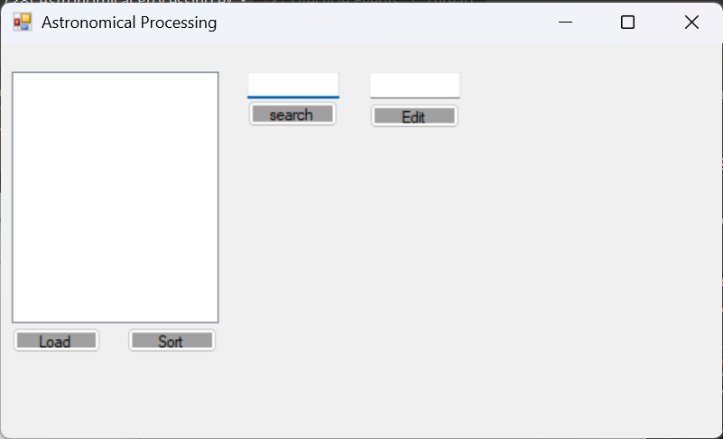

Question Three

Instructions
CITE uses GitHub as the primary Version Control System (VCS), you should create a GitHub account (you can use your existing account). Ensure your development computer has Visual Studio installed with all the appropriate features to create and develop a C# .Net application. Open Visual Studio and create a new project; ensure the GitHub settings have been updated to reflect your GitHub account. Create a new repository for the project and check you have a local and remote (Cloud) instance of the repository.
Complete the following Manage Version Control System template to answer this question.
Consult with your lecturer if you wish to use an alternative source control service. Any alternative source control must support a local desktop installation.
Manage Version Control System
VCS Name |  | Astronomical-Processing-Project-
Version Details |  | Main | Date | 27/10/2025
Supported Platforms |  | Visual Studio
Repository/Project Information |  |  |  |  | Yes | No
Has the cloud VCS account been created and named correctly? |  |  |  |  | ☒ | ☐
Has the basic project solution been created? |  |  |  |  | ☒ | ☐
Has the cloud VCS repository been created |  |  |  |  | ☒ | ☐
Does the cloud VCS repository have a readme file? |  |  |  |  | ☒ | ☐
Has the local source repository been created? |  |  |  |  | ☒ | ☐
Are the two VCS resources linked? |  |  |  |  | ☒ | ☐
Account Details Checklist
Repository Name: | Astronomical-Processing-Project-
URL | https://github.com/ifelippe01-ops/Astronomical-Processing-Project-.git
Local Source Control Screen Shot | 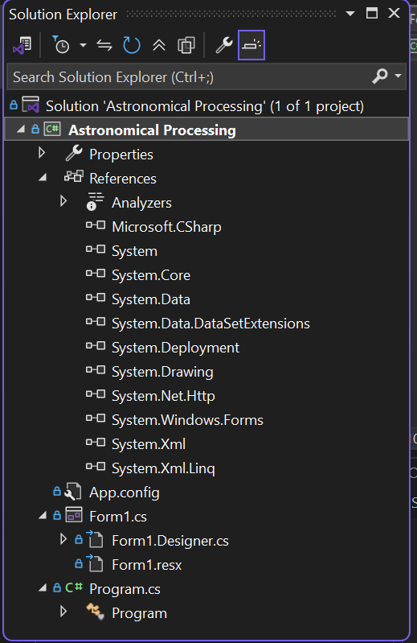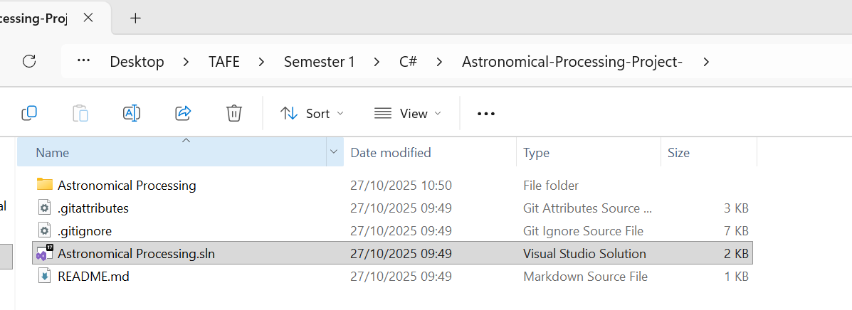
Cloud Screen Shot | 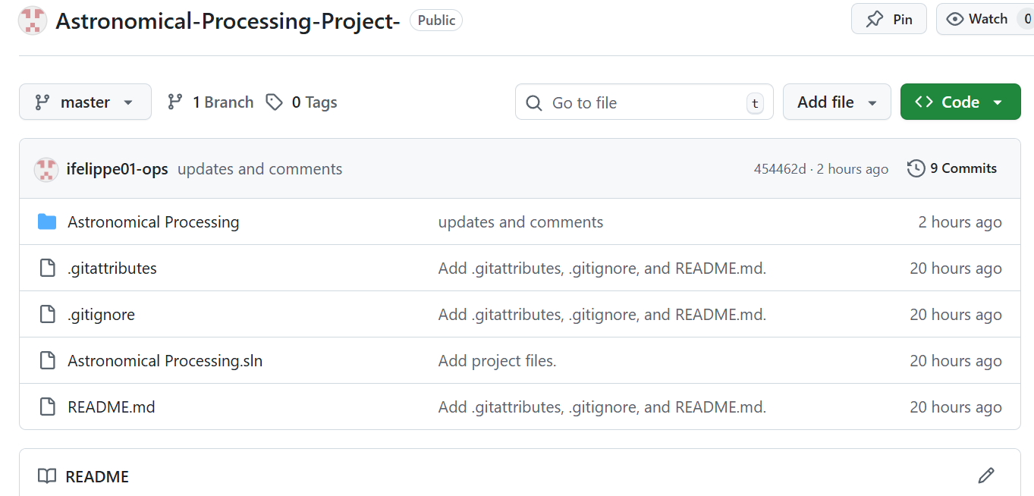

Question Four

Sprint One Approval
You will arrange for the Sprint One Project Specification document to be reviewed by the Lecturer/Assessor for approval, sign off and feedback before you start Question Five and Six.
Your submission for approval of the Sprint One Project Specification will include:
- Question One
  - Project Details,
  - Project Tasks,
  - Requirements (Functional and non-functional),
- Question Two
  - Design Specifications (detailed diagram of the GUI design),
  - GUI Layout,
- Question Three
  - Manage Version Control System details (screen shots from source control)
Approval (Lecturer/Assessor use only)
Approver Name | Title | Signature | Date | Approved?
Rupan Das | Teacher |  | 27/10 | Not yet
Lecturer Feedback
Review Non-Functional Requirement
Add a screenshot of Solution Explorer in Local Source Control Screen Shot
Complete the approval section
Review Algorithm and Pseudocode refer to session 2 Learning Materials.
Submit the doc again.

Meeting, discussion, and related notes
On the meeting we fixed the GitHub conflicts and ran through the changes to be done on this doc. It has now been changed accordantly to the feedback.

Question Five

Instructions
Fill in the two sections for the algorithm and pseudo code for the Binary Search and Bubble Sort. Refer to the Blackboard resources to ensure your answer reflects the differences between an Algorithm and Pseudo Code.
Algorithm and Pseudo Code
Binary Search
1. Ask the user to type a number as a target.  2. Check if the user entered an integer  If not, display “You must enter an integer” and stop.  3. Start the search:  Set the lowest position to 0 (the start of the list).  Set the highest position to the last index in the list.  Make an empty list called to store where the number is found.  4. While the search is within the list  Find the middle position between them.  If the middle is the target:  Add that position to the list of found indexes.  Search downwards for matches then search upwards. Add them if found.  If the number in the middle is bigger than target number, search the lower half of the list.  If the number in the middle is smaller, search the upper half.  5. When the search finishes:  If no indexes were found, show a message saying “Not found, try again.”  If one or more indexes were found, show a message like “Found at index(es): …” followed by its respective indexes. | BEGIN  SET target as an integer  IF target is not an integer  DISPLAY "You must enter an integer"  EXIT  END IF  SET foundIndexes as an empty list  SET lowBound = 0  SET highBound = max - 1  WHILE lowBound <= highBound DO  SET mid = (lowBound + highBound) / 2  IF myArray[mid] = target  ADD mid TO foundIndexes  SET down = mid - 1  WHILE down >= lowBound AND myArray[down] = target DO  ADD down TO foundIndexes  down - 1  END WHILE  SET up = mid + 1  WHILE up <= highBound AND myArray[up] = target DO  ADD up TO foundIndexes  up + 1  END WHILE  EXIT WHILE  ELSE IF myArray[mid] > target  SET highBound = mid - 1  ELSE  SET lowBound = mid + 1  END IF  END WHILE  IF foundIndexes IS EMPTY  DISPLAY "Not found, try again."  ELSE  DISPLAY "Found at index(es):" + foundIndexes  END IF  END
Bubble Sort
1. Start when the button is clicked.  2. Go through the list many times.  3. Each time, compare two numbers that are next to each other.  4. If the first number is bigger than the second, swap them.  5. Keep doing this until all numbers are in order.  6. Show the sorted list. |  | CLICK sort button  FOR outer = 0 TO MAX - 2:  FOR inner = 0 TO MAX - 2:  IF myArray[inner] > myArray[inner + 1]:  SWAP myArray[inner] and myArray[inner + 1]  END IF  END FOR  END FOR  Display sorted array in listBox  END

Question Six

Programming and Application Development
Once you have received approval from the Lecturer/Assessor, review and amend the Sprint Two Project Specification document based on the feedback. Complete the Scrum Board so you can begin work on the modifications for the Astronomical Processing application to satisfy the Client Requirements and Program Functionality.
As you progress and complete tasks, update the relevant Project Board. Avoid deleting items; simply add new items into the next column. This will provide historical evidence of your progress.
The Windows Prototype Application must comply with CITEMS organisational requirements for coding standards, comments, and documentation. For example, add suitable comments to all your code. Add a header comment at the top of the code as shown below, with your Name, Date, Version, and a program description.
// Your Name, Team Name, Sprint Number
// Date:
// Version:
// Name of the program
// Brief explanation of the program and list,
// Inputs, Processes, Outputs

Question Seven

Presentation of Sprint One
You should ensure that the programming code has the correct naming conventions and internal comments as per the CITEMS Policies and Standards. Notify your Lecturer to arrange a suitable time to present the final Sprint One documents and demonstrate the working Astronomical Processing application. This presentation will be assessing the you using simulated data in the array. The following Submission Requirements should be used to ensure all aspects of the assessment are covered.

Submission Requirements
Your submission for Sprint One will include:
Completed Project Specifications template,
Completed GUI Specification and notes,
Completed Manage Version Control System (project boards, file structure, etc),
Completed Feedback with Lecturer/Assessor approval,
Completed Algorithm and Pseudo Code,
Completed Solution Folder for the Astronomical Processing application.
The Sprint - You will demonstrate the program which must satisfy the following:
- The program must load random data into the array using a button click.
- The client must be able to click a button to bubble sort the data.
- The client must be able to enter search data and click a button to activate a binary search.
- All data is displayed in a List Box.
- Data can be edited.
- All error messages are demonstrated.
- Code comments are relevant.
- Demonstrate your workflow and code versioning within GitHub.
- Answer questions on all aspects of the Sprint One development and documents.

End of Sprint One

